Module Controller:

In order to run many disabled controllers (state is disabled) at once, we can use module controller

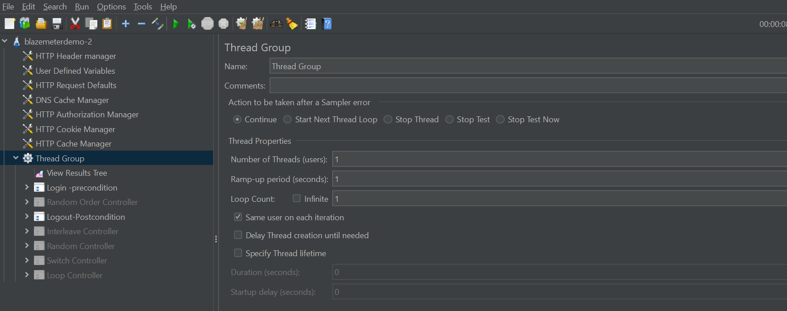

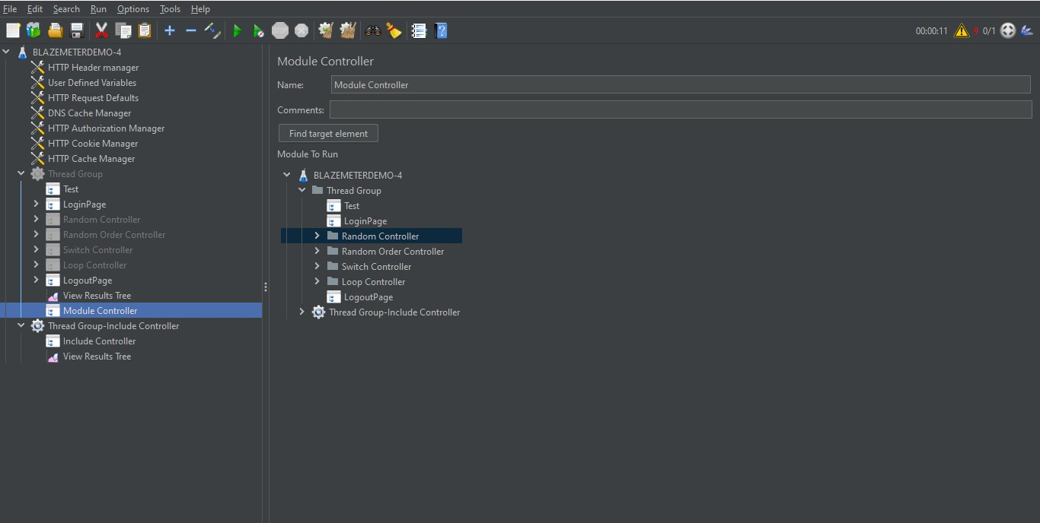

Include Controller

Create a new Test Plan🡪Add a new Test Fragment

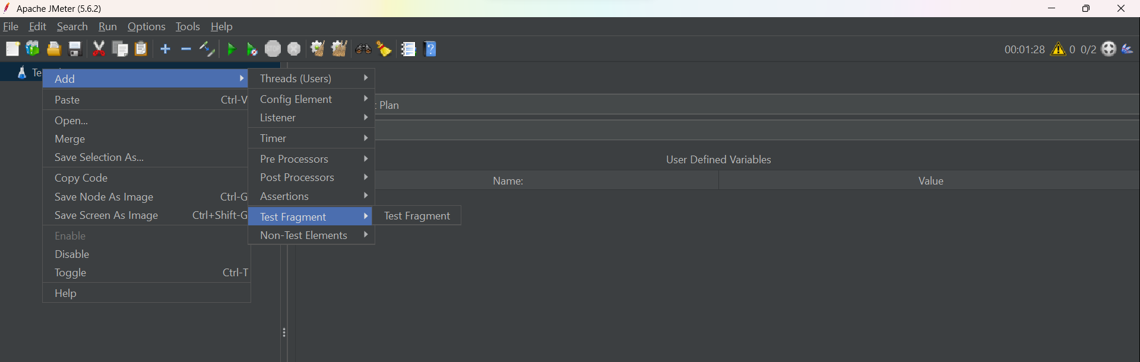

In Test Fragment🡪 add a HTTP sampler

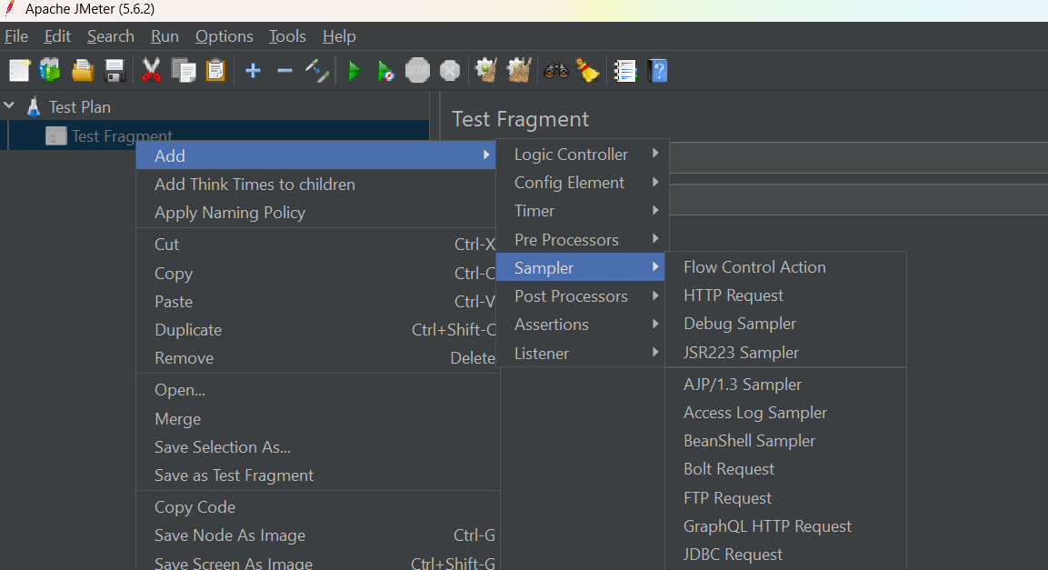

In the http request add blozedemo.com

Save the test plan as externelTest.jmx

Now open an exiting test plan 🡪 Add a threadgroup🡪add a include controller

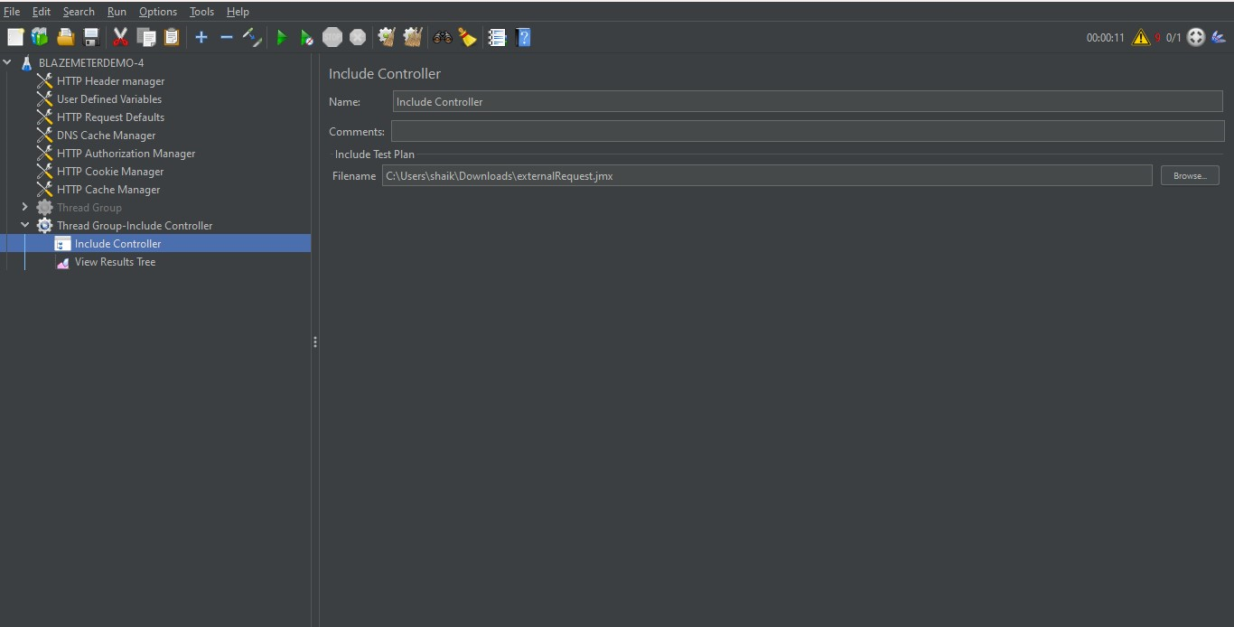

Underfile name click on browse button and select your script

User defined variables:

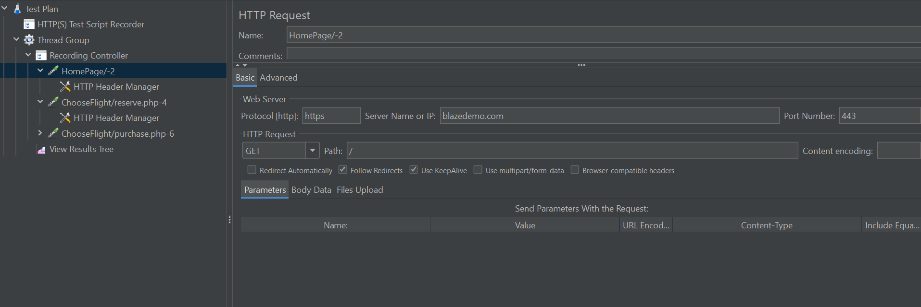

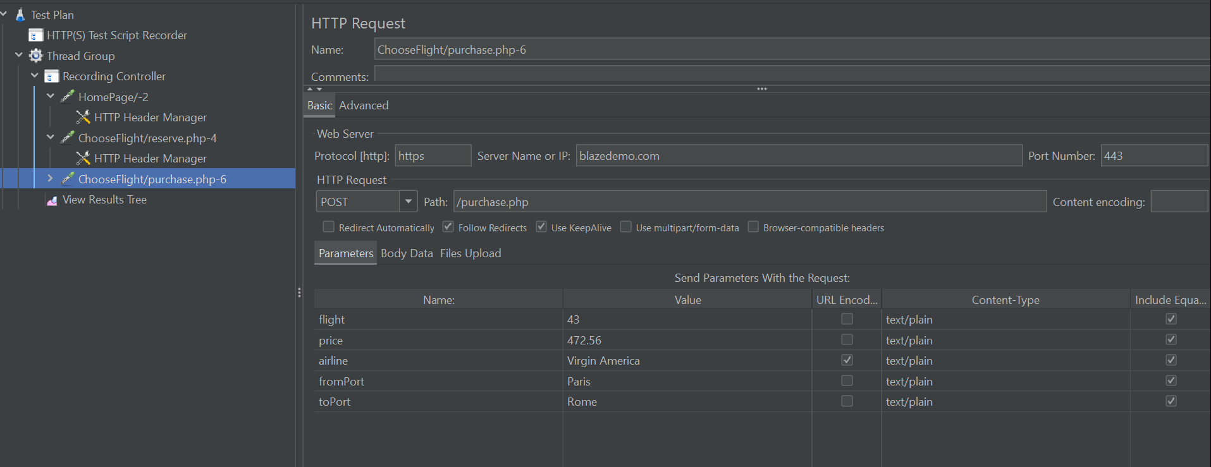

Add to the thread group a config element-> user defined variables

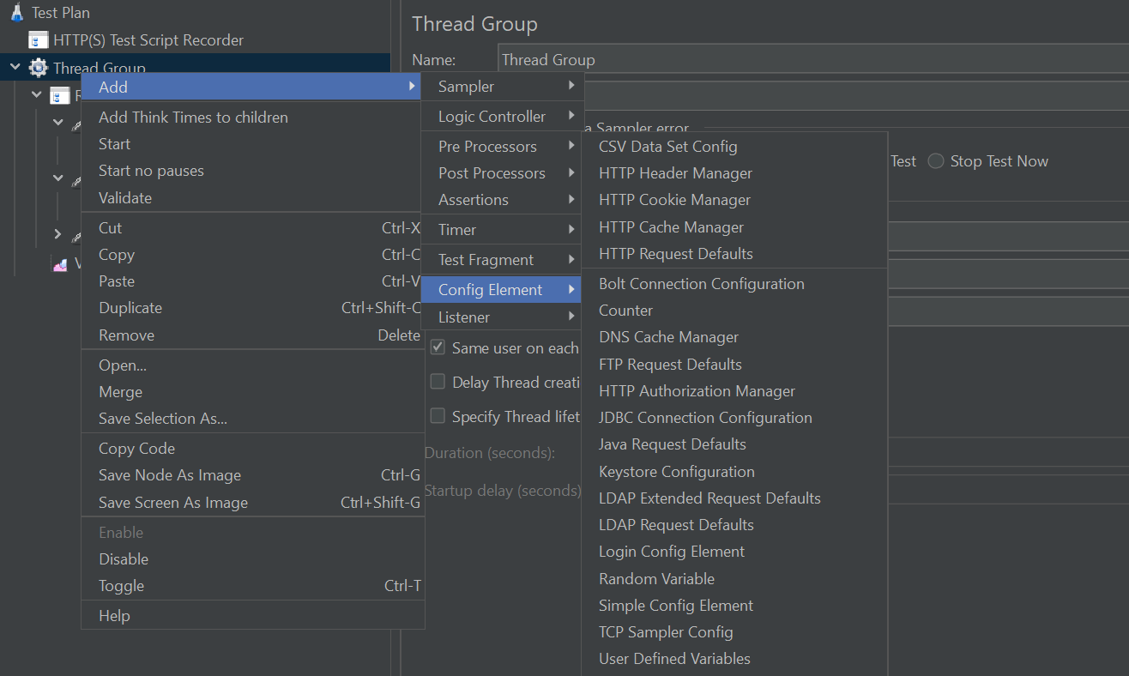

Go to the sampler where we have to pass the variables:

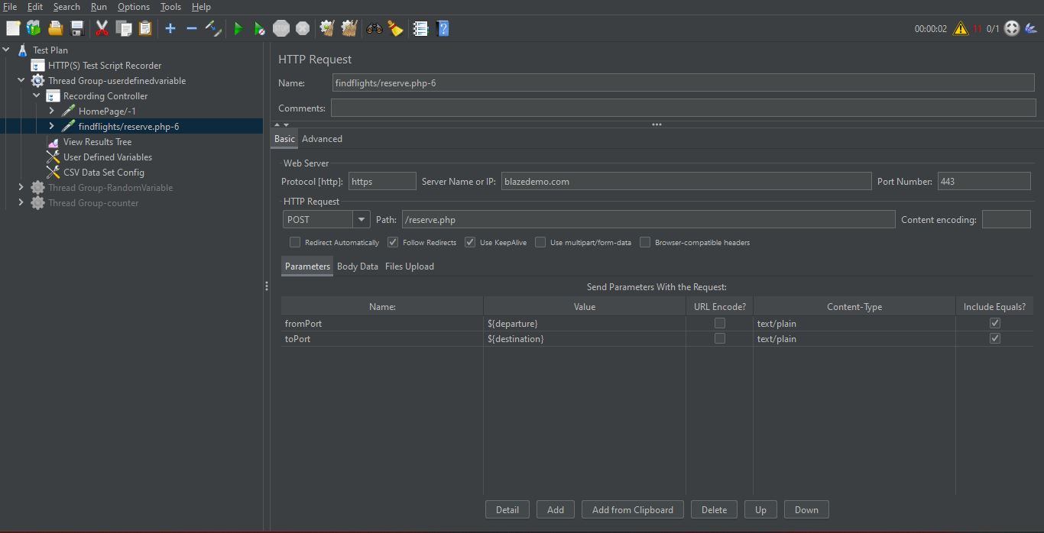

Call the variables in sampler as given below

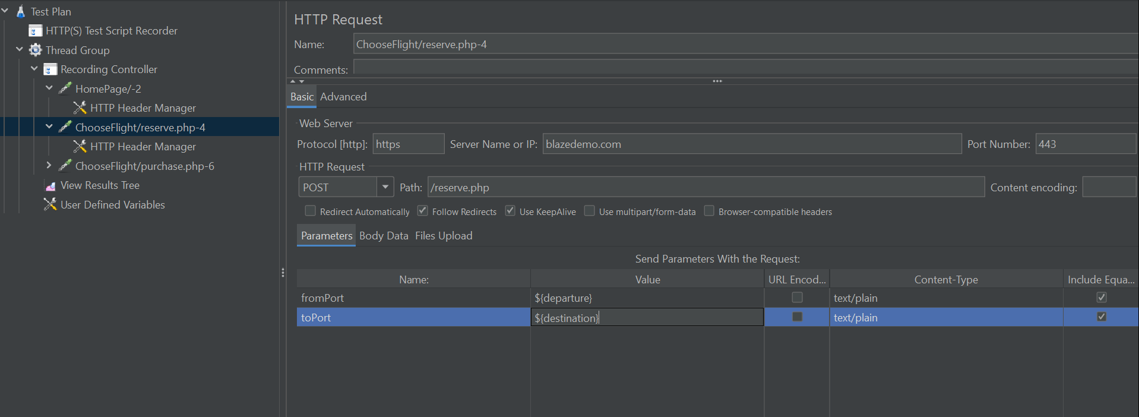

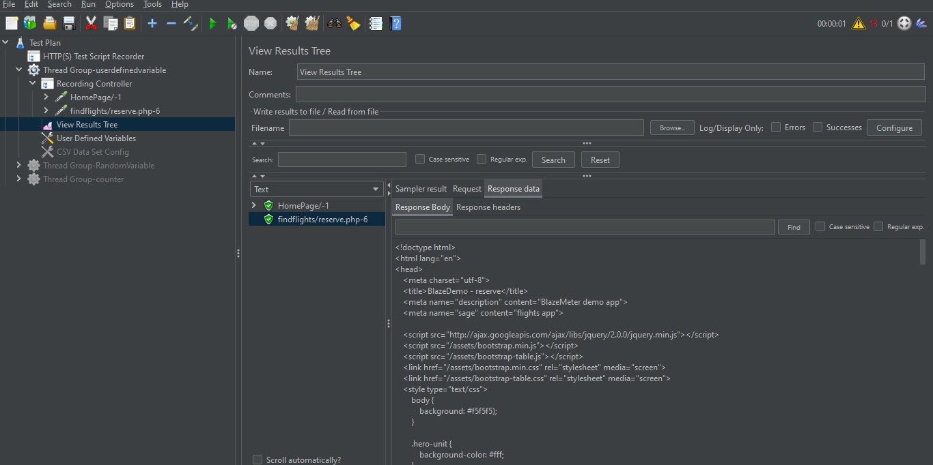

Random variable

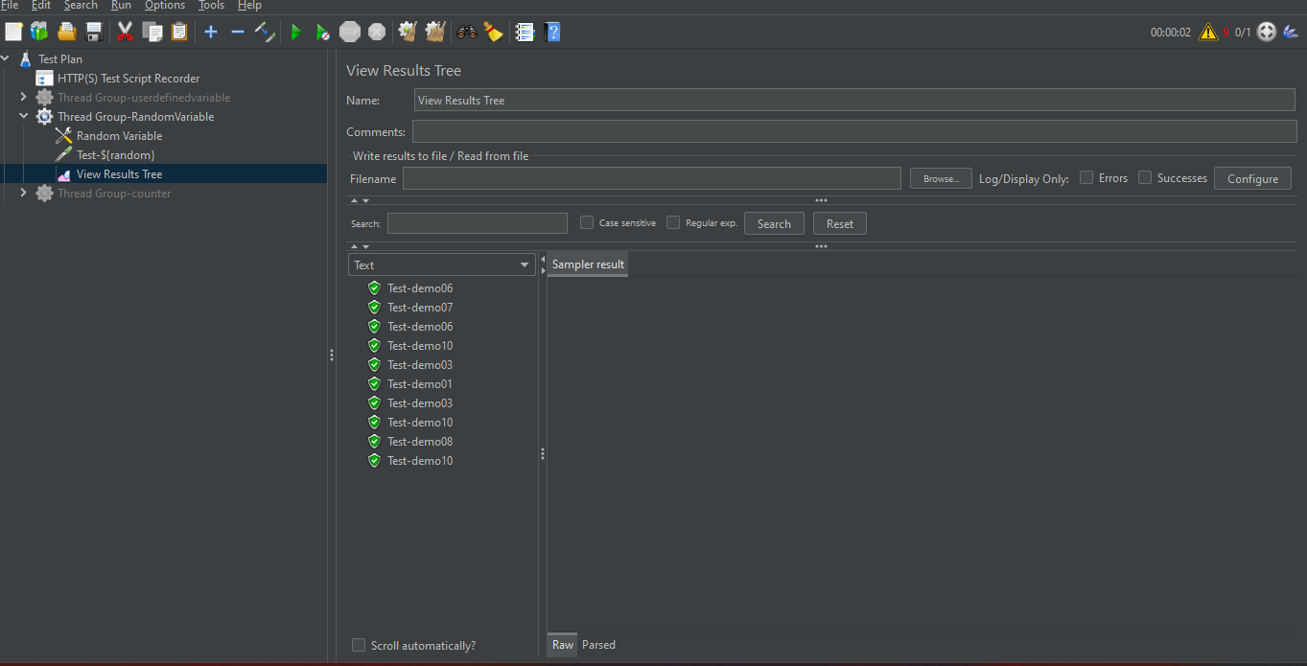

Count in Jmeter:-

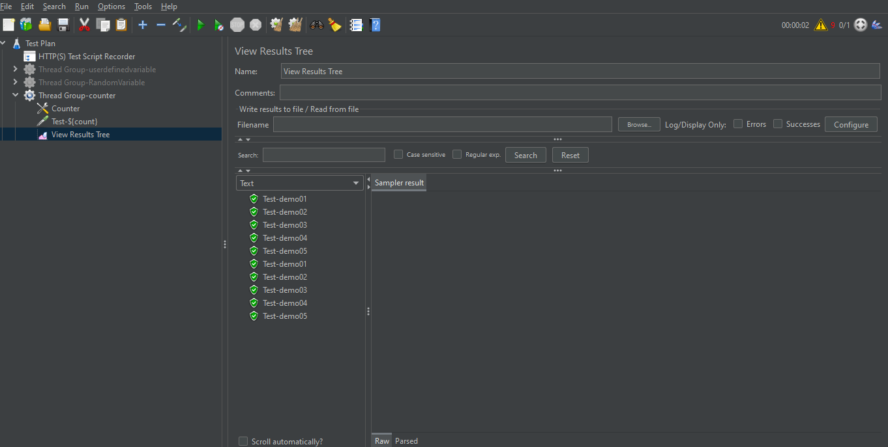

FTP sampler:

Download filezilla Client

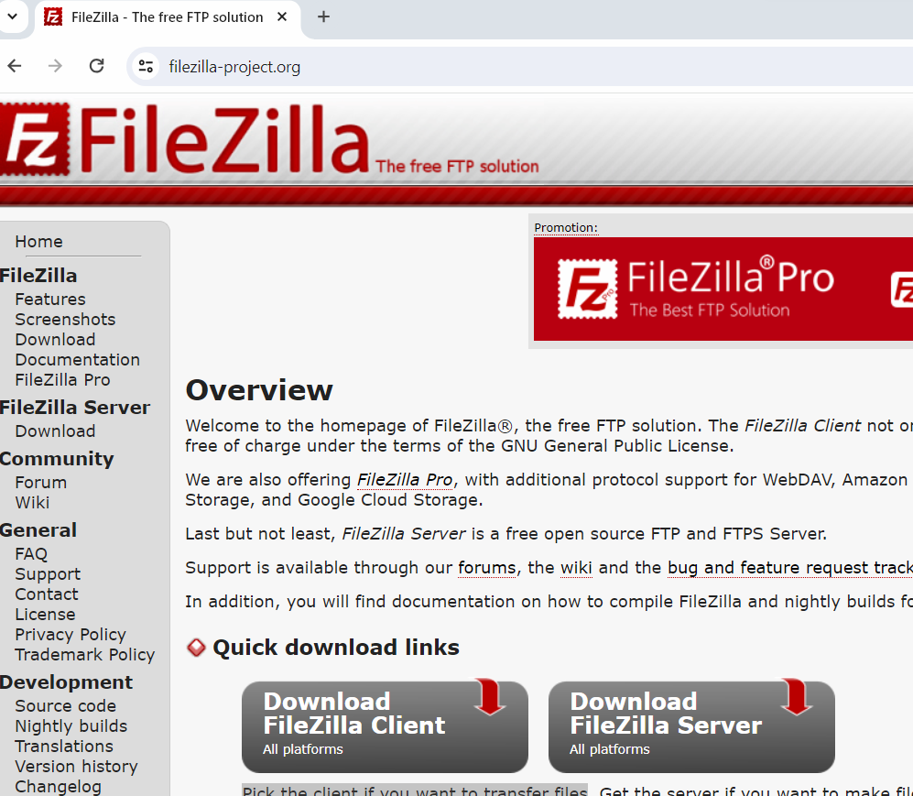

FTP server details:

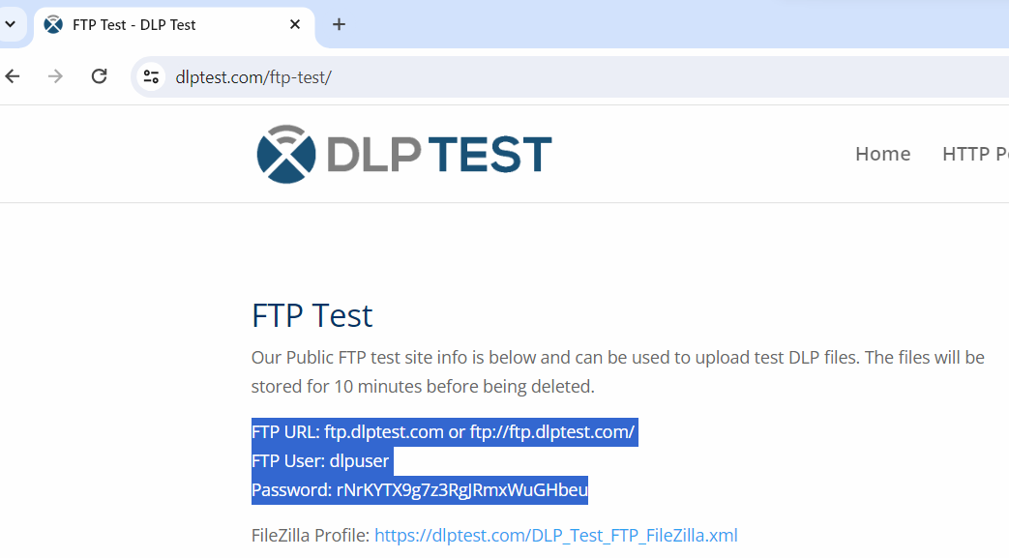

Give details in filezilla

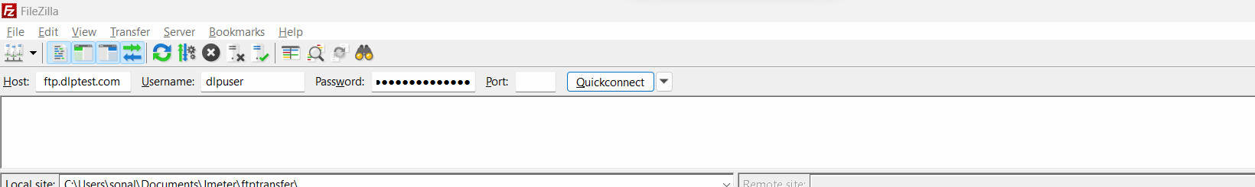

Create file in any folder on your machine

Now in filezilla you will find your file in the folder

Add FTP sampler in Jmeter

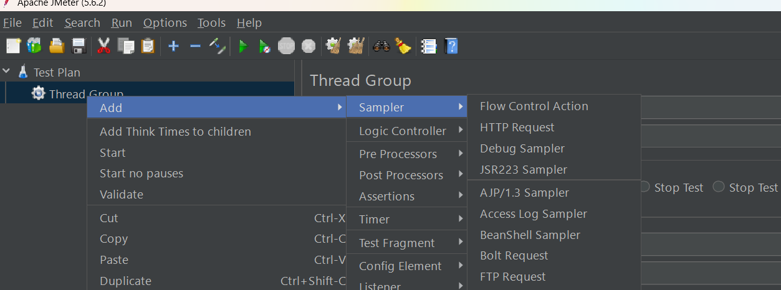

Timers:

Constant timers:

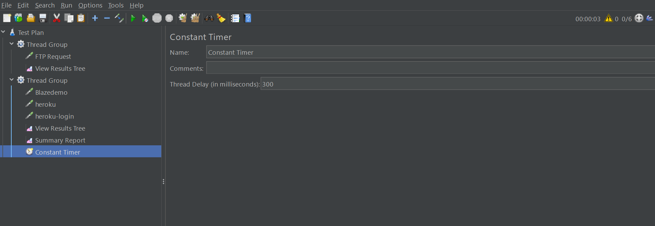

Uniform Random timer

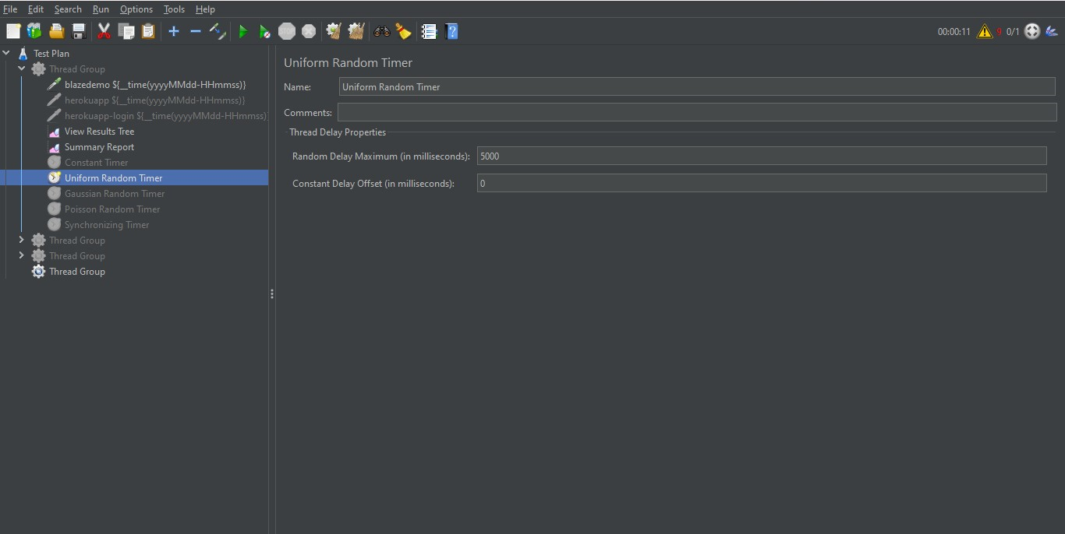

Gaussian Random timer

